**Best Sneakers Available in Japan: in 2021**

Not a very long time ago, there was a period when attending an event in a pair of sneakers was a very special way to flag yourself amongst your colleagues like a sartorial pariah. However, these thoughts have shifted in many ways. This transformation from running track towards the runway has been a slow procedure. Thanks to all leading designers and sneaker brands who in all possible directions have pushed the footwear to its edge. Some popular brands who pushed their models to the edge of success are Nike, Adidas, Jordan, Puma, etc.

Nike is at the top of the hype for many years. Nike brand shoes were first launched in 1972 by Bill Bowerman and Phil Knight. The journey of this brand began with the story of Blue Ribbon Sports back in 1964. Since then they have had to face many ups and downs, but finally, they are now established as a well-furnished company. Every brand tries to do something different from others. To make a difference in athlete performance, Adi Dassler; the founder of Adidas, started his journey in 1949. These sneakers are now widely used in the sports sector. Puma is said to be the third-largest sportswear manufacturer in the world. Adi Dassler's brother Rudolf Dassler founded this company in 1948. Puma launches the Super Atom, the first football boot that uses screw-in studs. Besides these, there are some more brands available that have arrived at today's demanding position over years.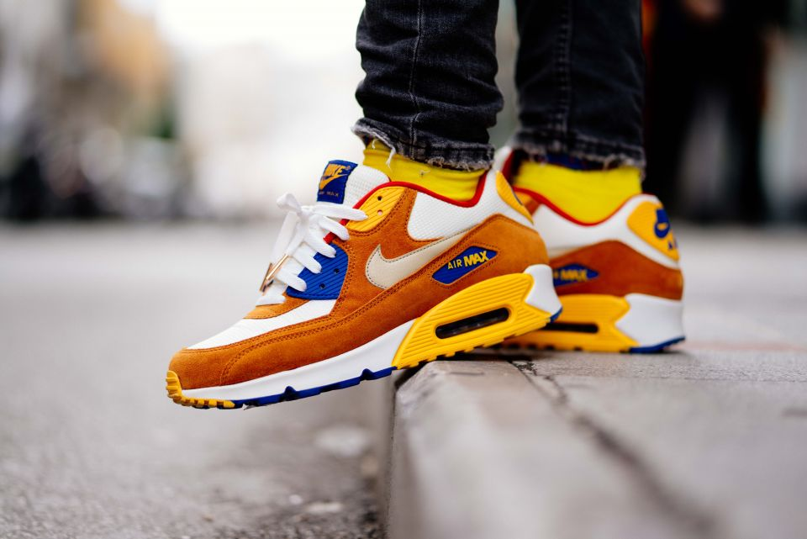

These brands have launched sneakers of different designs which attract both male and female travelers, tourists, players. People also can use these sneakers for regular jogging. In this article, we are going to note the top 8 models of sneakers and their brands available on Amazon.

**Top Models**:

#1 Adidas ADIPACE VS Sneakers Men’s

#2 Nike 812654 - 011 Tanjun Sneakers

#3 Nike WMNS Tanjun Women’s Sneakers

#4 Adidas Men’s Running Shoes

#5 PUMA Women’s Carina Sneaker

#6 Nike AQ7481 - 002 Downshifter 9

#7 Nike 749794 - 010 MD Runner 2 Men’s

#8 PUMA Men’s Smash V2

**#1 Adidas ADIPACE VS Sneakers Men’s**

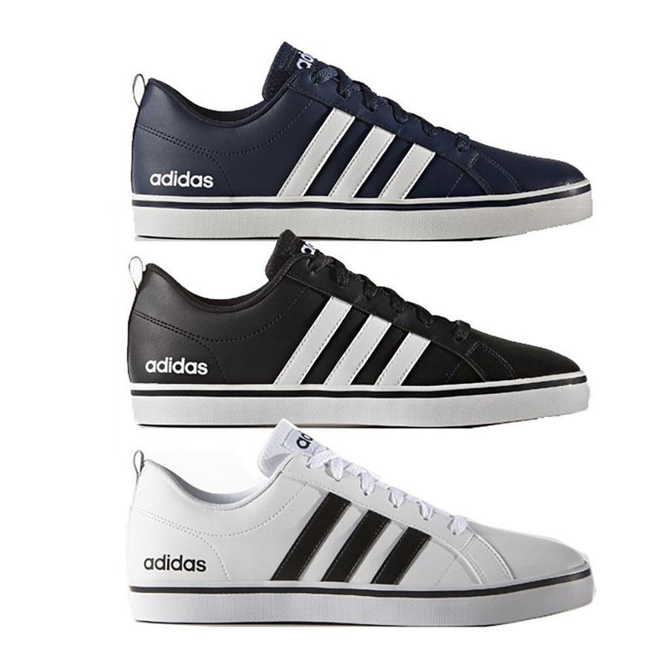

**Rating: ★★★★✮**

**4.2 out of 5**

**20,495 ratings**

**Review:**

Adidas ADIPACE VS Sneakers are one of the top-rated amongst all other sneakers available. These sneakers are found in different comfortable sizes, making it easy for consumers to choose according to their feet length. Moreover, this model provides about ten to eleven variants, which impact customers' minds.

The specialty of ADIPACE VS is the three stripes on the outer part of the shoe. The interior is also designed with a casually punched three-stripe. These stripes are constructed of synthetic leather. Its width is slim and also the bottom part is thin. So, you might not find that much shock absorbency on concrete. Adidas ADIPACE VS is a great choice for jogging and casual use.

These Adidas sneakers are not waterproof. This might be one disadvantage of this shoe. But anyway, the original copies of Adidas are admired worldwide. Rather than that, I recommend this sneaker as a perfect choice for people of all sectors.

[See more reviews.](https://youtu.be/2n_2vrb-NCI)

**Specifications:**

|  |  |
| --- | --- |
| **Brand** | **Adidas** |
| **Product Name** | **ADIPACE VS** |
| **Material** | **Synthetic fiber, synthetic leather, rubber sole** |
| **Available Size** | **22.0 - 32.0 cm** |
| **Sole Thickness** | **1.5 cm** |
| **Closure** | **Lace Up** |

|  |
| --- |
| [Check it on Amazon](https://www.amazon.co.jp/-/en/Adidas-Adipace-Sneakers-Men%E2%80%99s-Size/dp/B08BX4NNFM/ref=sr_1_4?dchild=1&keywords=%EF%BD%81%EF%BD%84%EF%BD%89%EF%BD%84%EF%BD%81%EF%BD%93%2B%E3%82%B9%E3%83%8B%E3%83%BC%E3%82%AB%E3%83%BC&qid=1620815418&sr=8-4&th=1) |

**#2 Nike 812654 - 011 Tanjun Sneakers**

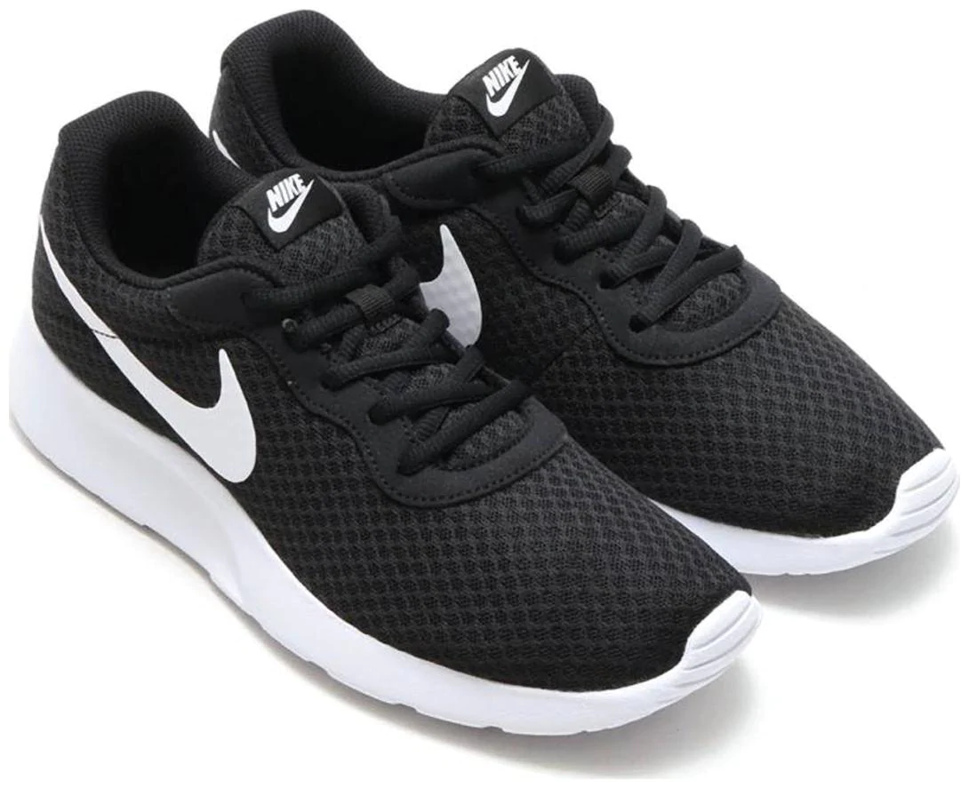

**Rating: ★★★★✮**

**4.4 out of 5**

**10,897 ratings**

**Review:**

Being available with different stylish variants, Nike 812654 - 011 Tanjun Sneakers are also found in many comfortable sizes which makes it very clear to the buyers which one to choose and which one not to.

Designed with a clean and contemporary design and the finishing touch is also very smart. The color tone which is used while designing these shoes makes this more stylish. Nike Tanjun Sneakers can be worn with any outfit and they will surely make you look even cooler. These shoes are very light and you can easily walk for as long as you want.

Most of the customers gave satisfactory opinions after buying this Nike product. It is safe if you order a half-centimeter of larger size than your feet size as some have complained about this issue after buying. Rather than that, there is no issue with the product material quality, product design, style, and even with the bottom part. I also recommend this as a very good choice. [See more reviews.](https://youtu.be/DGcdc9H-tuA)

**Specifications:**

|  |  |
| --- | --- |
| **Brand** | **Nike** |
| **Manufacturer** | **Nike** |
| **Product Dimension** | **30.2x19.1x10.4 cm** |
| **Available Size** | **24.0 - 32.0 cm** |
| **Sole Thickness** | **2 cm** |
| **Weight** | **400 gm** |

|  |
| --- |
| [Check it on Amazon](https://www.amazon.co.jp/-/en/Nike-812654-Tanjun-Sneakers-black/dp/B00XWPX0TI/ref=sr_1_13?dchild=1&keywords=nike%2B%E3%82%B9%E3%83%8B%E3%83%BC%E3%82%AB%E3%83%BC&qid=1620814694&sr=8-13&th=1) |

**#3 Nike WMNS Tanjun Women’s Sneakers**

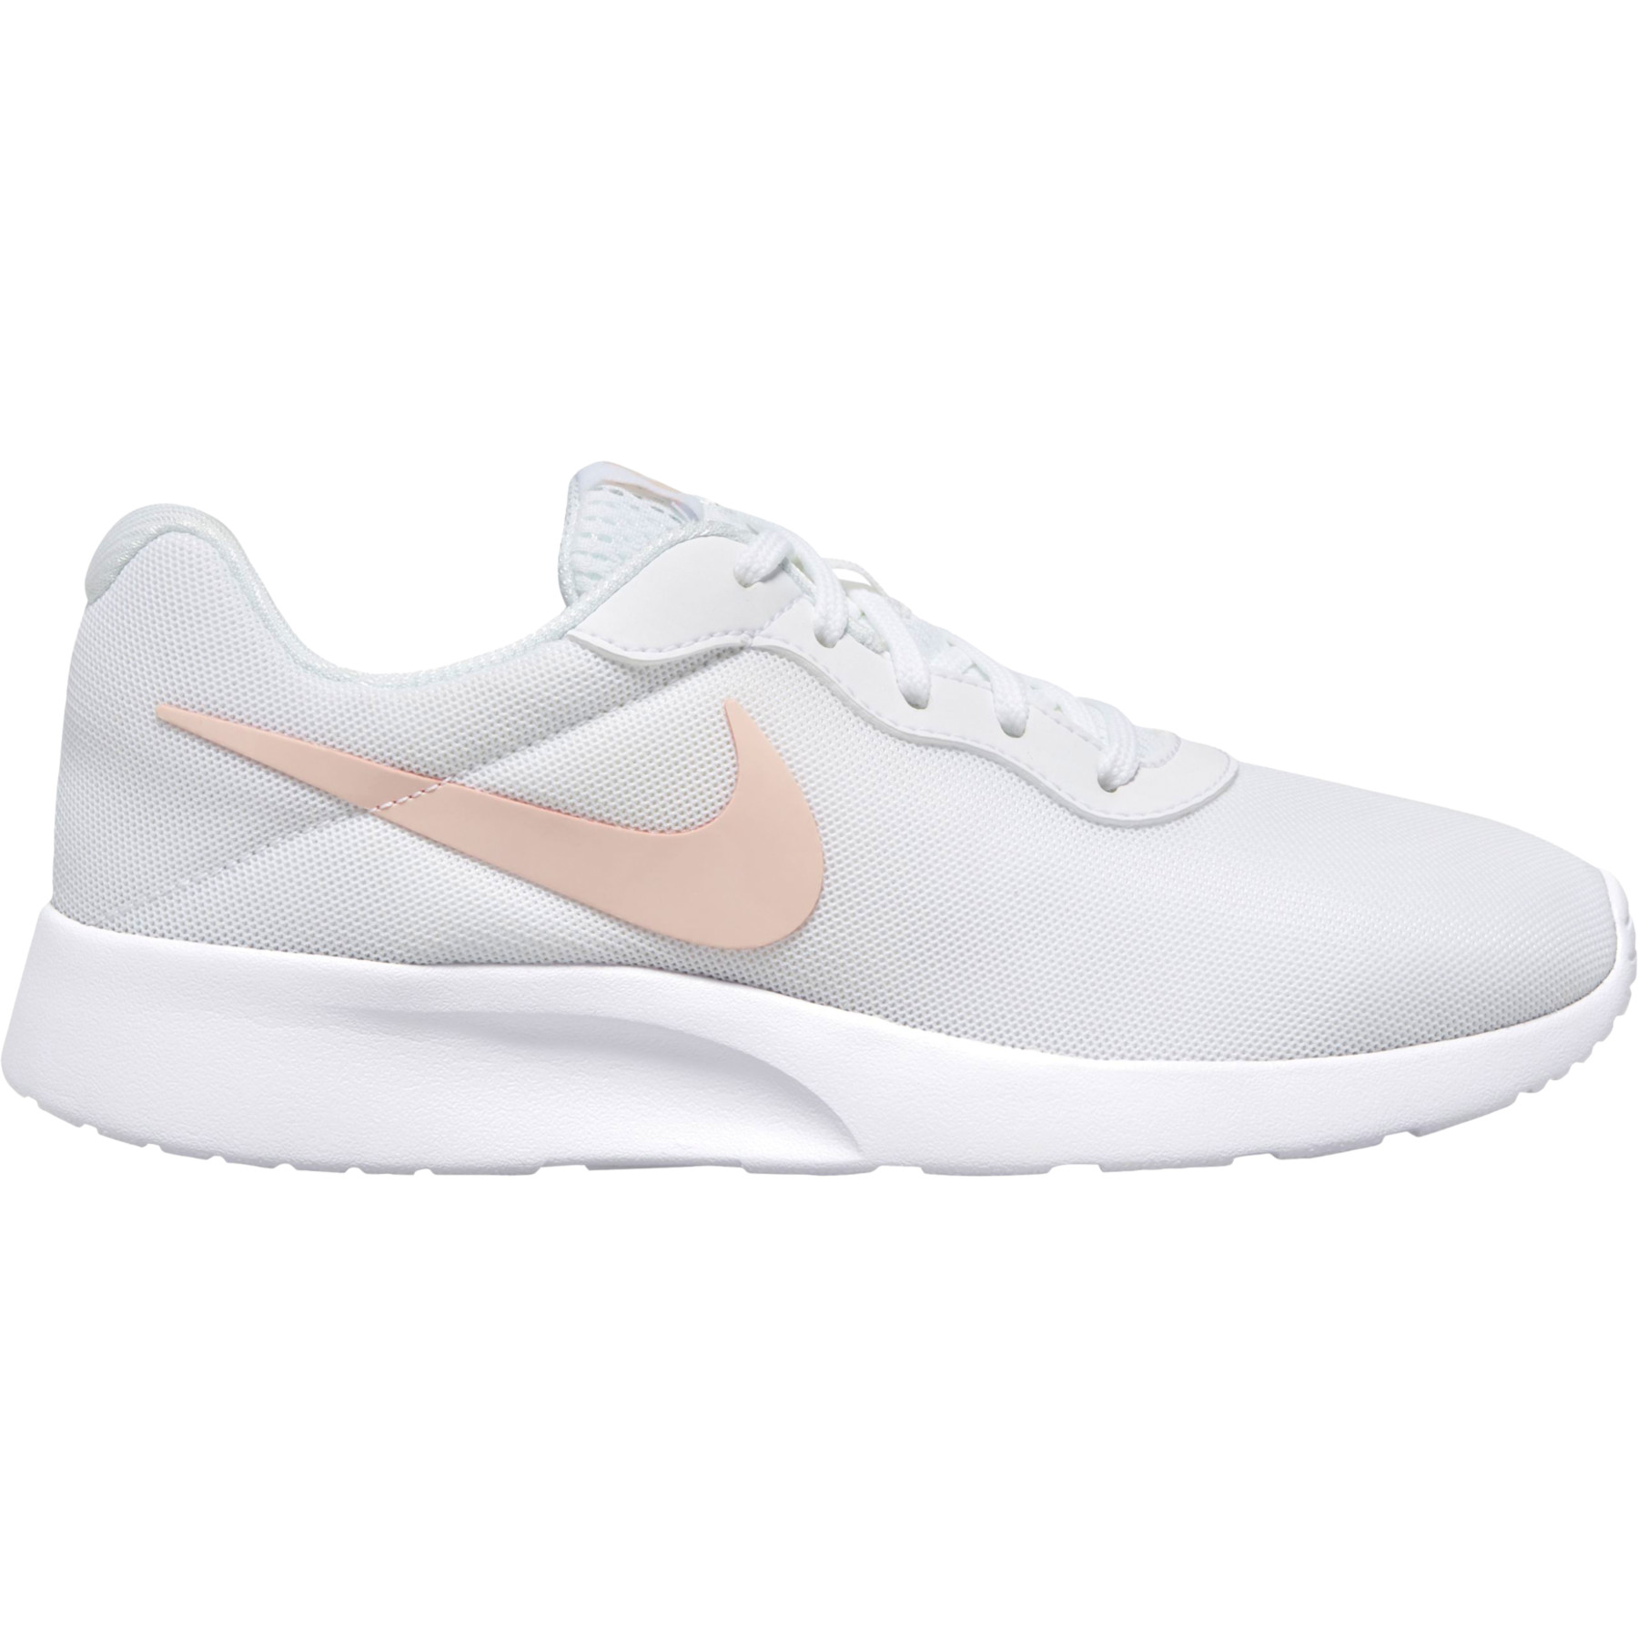

**Rating: ★★★★✮**

**4.5 out of 5**

**9,022 ratings**

**Review:**

This Nike WMNS Tanjun is Nike's specially designed sneakers for women. One amazing point about this product is, it ranks #1 in Amazon best seller women's walking shoes raking. It makes a very clear point at first glance why people should choose this sneaker. Constructed with high-quality synthetic fiber material, excellent heel height, lace-up closure gives it a perfect finishing.

Some curious customers may think for what reason the "Tanjun" word stands for. "Tanjun" stands for "Simple". The Nike Women's Tanjun owns an elegant, user-friendly, simple, and comfortable design. Women enjoy walking, jogging, and traveling with this shoe. The diamond-patterned mesh design on the outer part of the sneaker makes it look even more gorgeous. This pair is strongly recommended for those who want a comfortable walk. With that note, one small suggestion I want to add up. Buy a half or one centimeter above your original foot size. It is safe. [Some more reviews](https://www.youtube.com/watch?v=rBnoxvD7XVU)

**Specifications:**

|  |  |
| --- | --- |
| **Brand** | **Nike** |
| **Manufacturer** | **Nike** |
| **Product Name** | **Tanjun Women’s Sneakers** |
| **Material** | **Synthetic fiber** |
| **Available Size** | **22.5 - 29.0 cm** |
| **Sole Thickness** | **2 cm** |
| **Closure** | **Lace Up** |
| **Product Dimension** | **33x23x11 cm** |
| **Weight** | **700 gm** |

|  |
| --- |
| [Check it on Amazon](https://www.amazon.co.jp/-/en/Nike-Sneakers-WMNS-TANJUN-812655/dp/B0059G90LA/ref=sr_1_21?dchild=1&keywords=nike%2B%E3%82%B9%E3%83%8B%E3%83%BC%E3%82%AB%E3%83%BC&qid=1620814694&sr=8-21&th=1) |

**#4 Adidas Men’s Running Shoes**

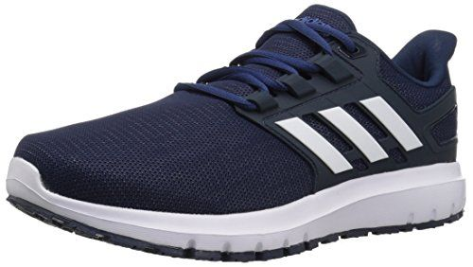

**Rating: ★★★★✬**

**4.2 out of 5**

**8,379 ratings**

**Review:**

Adidas Falcon Run is the best running sneaker for men available in Japan. This is one of the best-selling running shoes available on Amazon. Available in many variants and colors, which makes it look more attractive; the high-quality leather material gives it a comfortable feel. The soft cushioning allocates comfortable footwork with this shoe. That's why it is one of the best choices for travelers, sportsmen, and even for a casual walk. It can also make your jogging more fun.

With all the good quality specifications, these Adidas Falcon Run sneakers can be available at a cheap rate which is very satisfying to many buyers as not everyone can afford to buy high-budget sneakers. Some people may complain about sole quality, but it depends upon how you use your material. If you rush to your materials, nothing is going to last long. As far as I have judged, this can be a good choice for every sector. [See more reviews.](https://www.youtube.com/watch?v=6RQnzjuUEj0)

**Specifications:**

|  |  |
| --- | --- |
| **Brand** | **Adidas** |
| **Manufacturer** | **Adidas** |
| **Product Name** | **Adidas Falcon Run** |
| **Material** | **Leather** |
| **Available Size** | **24.5 - 31.0 cm** |
| **Sole Thickness** | **2.5 cm** |
| **Closure** | **Lace Up** |
| **Sole Material** | **Rubber** |
| **Weight** | **400 gm** |

|  |
| --- |
| [Check it on Amazon](https://www.amazon.co.jp/-/en/adidas-FALCONRUN-Running-Current-24-5cm-32-0cm/dp/B07JNFCMZ7/ref=sr_1_3?dchild=1&keywords=%EF%BD%81%EF%BD%84%EF%BD%89%EF%BD%84%EF%BD%81%EF%BD%93%2B%E3%82%B9%E3%83%8B%E3%83%BC%E3%82%AB%E3%83%BC&qid=1620815418&sr=8-3&th=1) |

**#5 PUMA Women’s Carina Sneaker**

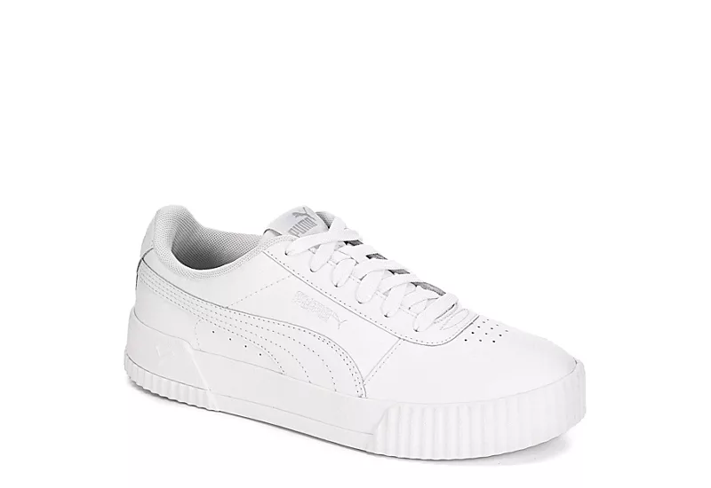

**Rating: ★★★★✬**

**4.6 out of 5**

**9,139 ratings**

**Review:**

PUMA Women's Carina Sneaker is one of the most exclusive models. As you can find out around forty different variants of these sneakers which is quite impressive. Ladies would love to have at least one of these variants for sure.

Now if we come to product material, almost all varieties are built of synthetic material. One important drawback of this sneaker is, it is not water-resistant which may cause an issue while on a heavy rainy day. Otherwise, it is very comfortable for running and jogging. Every woman will surely want to have these PUMA shoes. More than eighty percent of customers rated this model five out of five.

[See more reviews.](https://www.youtube.com/watch?v=YsfPQBpFqgc)

**Specifications:**

|  |  |
| --- | --- |
| **Brand** | **PUMA** |
| **Manufacturer** | **PUMA** |
| **Product Name** | **Women’s Carina Sneakers** |
| **Material** | **Synthetic** |
| **Available Size** | **22.5 - 28.0 cm** |
| **Closure** | **Lace Up** |
| **Sole Material** | **Rubber** |
| **Product Dimension** | **29.5x18.24x10.54 cm** |
| **Weight** | **1.36 Kg** |

|  |
| --- |
| [Check it on Amazon](https://www.amazon.co.jp/-/en/dp/B07HJLYSQC/ref=sr_1_22?dchild=1&keywords=%E3%83%97%E3%83%BC%E3%83%9E%2B%E3%82%B9%E3%83%8B%E3%83%BC%E3%82%AB%E3%83%BC&qid=1620815687&sr=8-22&th=1) |

**#6 Nike AQ7481 - 002 Downshifter 9**

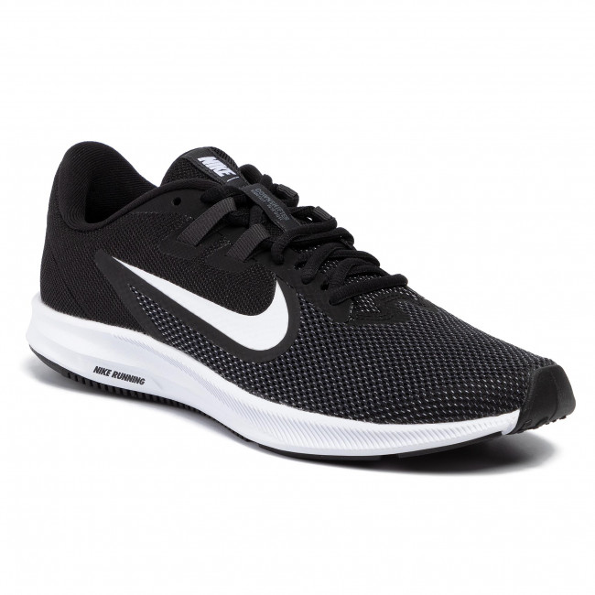

**Rating: ★★★★✬**

**4.3 out of 5**

**7,967 ratings**

**Review:**

Nike Downshifter 9 is another very popular model of the Nike brand. Its building process is very nice. The upper portion is built of lightweight mesh for proper breathability and comfort. And for structural support, the knit mesh is kept tight which also provides support for your balancing. It is a very good choice for school shoes, walking shoes. But it might be a little uncomfortable for jogging and for the sportsmen. Anyway, the build quality is satisfying and the price is also very affordable. So, you can also have good products at a cheap rate.

For its tight structure, some people find this sneaker irritating to use. It is said that, because of the tight border, the shoe hits the ankle, and sometimes it is very painful. So it is highly recommended that while buying this sneaker, you must take one centimeter bigger than your original feet size. [See more reviews.](https://www.youtube.com/watch?v=WAjgMBaiM7A)

**Specifications:**

|  |  |
| --- | --- |
| **Brand** | **Nike** |
| **Product Name** | **Downshifter 9** |
| **Available Size** | **24 - 33 cm** |
| **Closure** | **Lace Up** |
| **Sole Material** | **Rubber** |
| **Product Dimension** | **33x23x13 cm** |
| **Weight** | **345.86 gm** |

|  |
| --- |
| [Check it on Amazon](https://www.amazon.co.jp/-/en/BQ3204/dp/B07NLV8LQ9/ref=sr_1_8?dchild=1&keywords=nike%2B%E3%82%B9%E3%83%8B%E3%83%BC%E3%82%AB%E3%83%BC&qid=1620814694&sr=8-8&th=1) |

**#7 Nike 749794 - 010 MD Runner 2 Men’s**

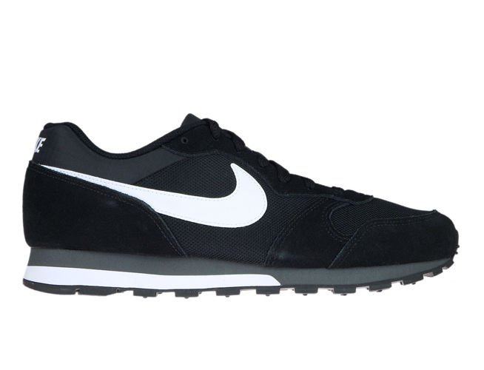

**Rating: ★★★★✬**

**4.3 out of 5**

**5,332 ratings**

**Review:**

Nike MD Runner 2 is only available in one variant. The upper part of these sneakers is constructed with synthetic breathable mesh and a suede overlay. The sole is thick which is made of rubber and it provides a good heel height too.

Nike users are all comfortable with this product and if someone goes for a second or third pair, he always sticks to Nike. One problem which I think many of the consumers complained about is, the size gets short. So it is hardly recommended that while ordering, don't forget to put at least one centimeter extra than your original feet size.

Rather than that, this MD Runner 2 is good and comfortable for running and jogging. This is also a good option for hill trekking and travel lovers. Being this product so lightweight, you can easily carry your pair if it is necessary. Finally in conclusion, this is a very budget-friendly product. [See more reviews.](https://www.youtube.com/watch?v=il3TjkcvNEk)

**Specifications:**

|  |  |
| --- | --- |
| **Brand** | **Nike** |
| **Manufacturer** | **Nike** |
| **Product Name** | **MD Runner 2** |
| **Material** | **Synthetic** |
| **Available Size** | **24 - 29 cm** |
| **Closure** | **Lace Up** |
| **Sole Material** | **Rubber** |
| **Sole Thickness** | **2 cm** |
| **Product Dimension** | **24x9x5 cm** |
| **Weight** | **400 gm** |

|  |
| --- |
| [Check it on Amazon](https://www.amazon.co.jp/-/en/Nike-Runner-Men-Black-Sneakers/dp/B00PYDTBMQ/ref=sr_1_6?dchild=1&keywords=nike%2B%E3%82%B9%E3%83%8B%E3%83%BC%E3%82%AB%E3%83%BC&qid=1620814694&sr=8-6&th=1) |

**#8 PUMA Men’s Smash V2**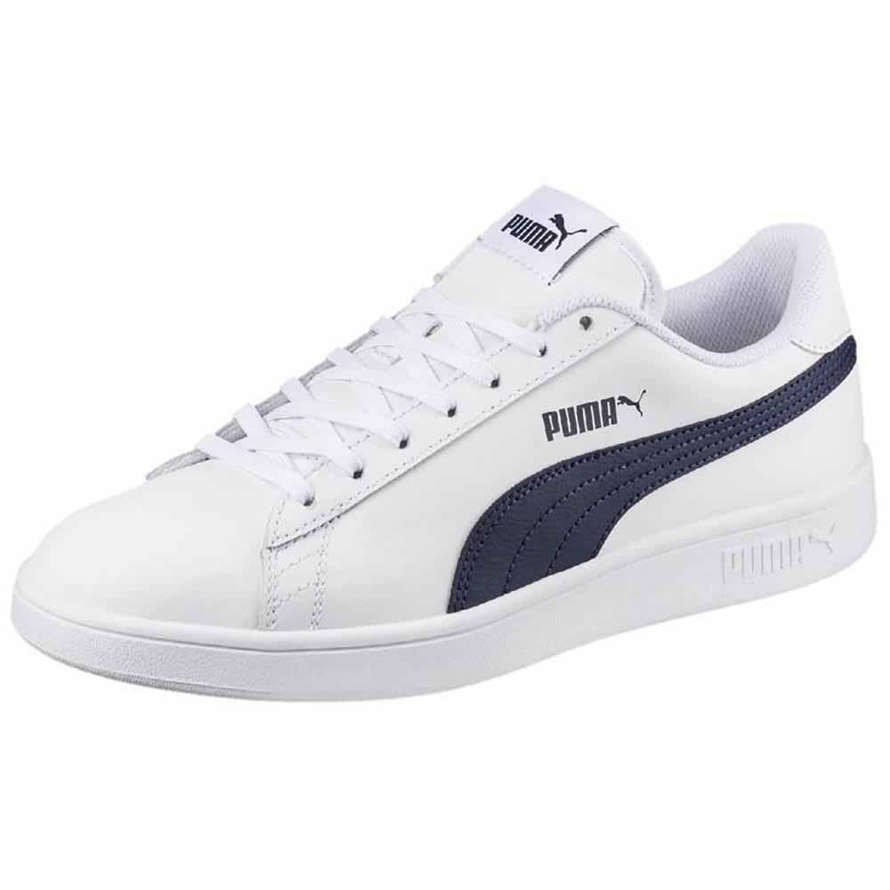

**Rating: ★★★★✬**

**4.6 out of 5**

**4,043 ratings**

**Review:**

PUMA Men's Smash V2 is a popular choice as a running and jogging pair. Made with fabric and synthetic and the sole part is constructed with rubber. The sole grip is also very supportive. You can easily adjust it with your feet as many sizes are available. The shoe is also wide enough which gives you proper comfort while running or walking.

Customers are truly very satisfied with this amazing product. Be sure about the original and fake product before buying. These sneakers can be a very good choice as a gift too. The design and outlook are pretty simple which add more attraction to some customers. Besides, this PUMA Smash V2 is available in many color combinations. So while choosing, you won't have to stick to one color only. Its closure type is a little different from other products.

After reviewing many products, I recommend PUMA Men's Smash V2 as one of the best running shoes available in Japan. The only disadvantage is, this product is not water-resistant. [See more reviews.](https://www.youtube.com/watch?v=msp68hynlyA)

**Specifications:**

|  |  |
| --- | --- |
| **Brand** | **PUMA** |
| **Manufacturer** | **PUMA** |
| **Product Name** | **Men’s Smash V2** |
| **Material** | **Fabric and Synthetic** |
| **Available Size** | **21 - 32 cm** |
| **Closure** | **Hook and Loop Fastener** |
| **Sole Material** | **Rubber** |
| **Product Dimension** | **27.94x17.01x9.9 cm** |
| **Weight** | **658 gm** |

|  |
| --- |
| [Check it on Amazon](https://www.amazon.co.jp/-/en/36520818/dp/B07TQ84JJ5/ref=sr_1_23?dchild=1&keywords=%E3%83%97%E3%83%BC%E3%83%9E%2B%E3%82%B9%E3%83%8B%E3%83%BC%E3%82%AB%E3%83%BC&qid=1620815687&sr=8-23&th=1) |

**Conclusion:**

The sneakers models and brands stated above are the most reviewed and best-rated in Japan. All the sneakers are good from different parts of their actions. Even not all the sneakers are for the same purpose. Some are good for walking and jogging, some are good for traveling and tracking, while some of them are best for athletes. Some are for men and some others are specially built for women. So while choosing, you need to have a close look at the product model, specification, and price too.